**Assignment -2**

Flask application

|  |  |
| --- | --- |
| Assignment Date | 12 November 2022 |
| Student Name | Sathish Kumar C |
| team id | PTN2022TMID50612 |
| Maximum Marks | 2 Marks |

Question:

1. Create a flask app
2. Add home page, about page
3. Add bootstrap
4. Add sign in page and signup page with data connectivity.

Flask app:

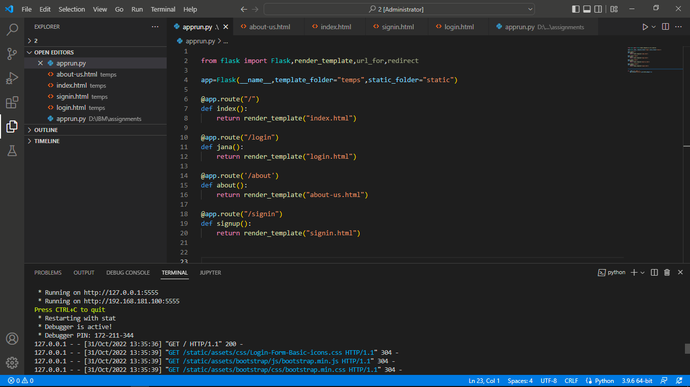

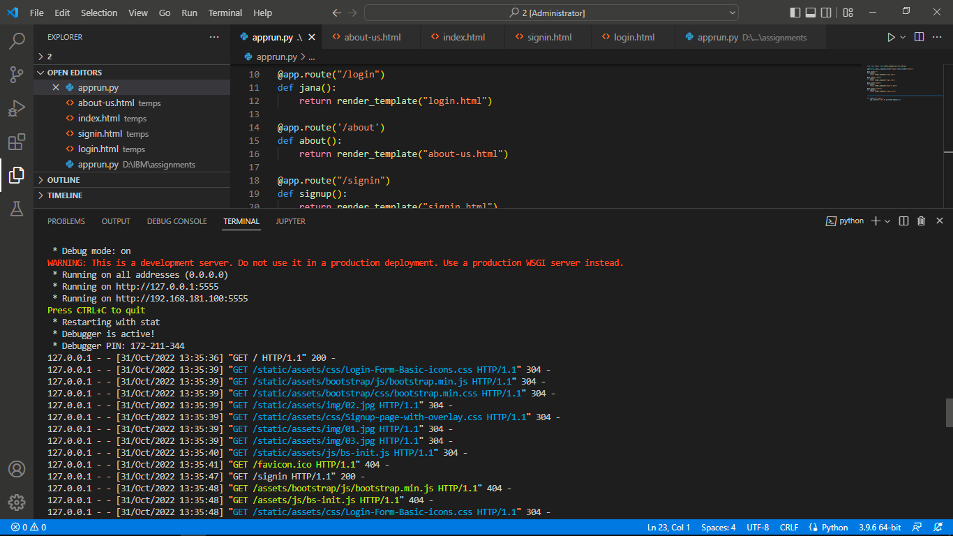

Home page:

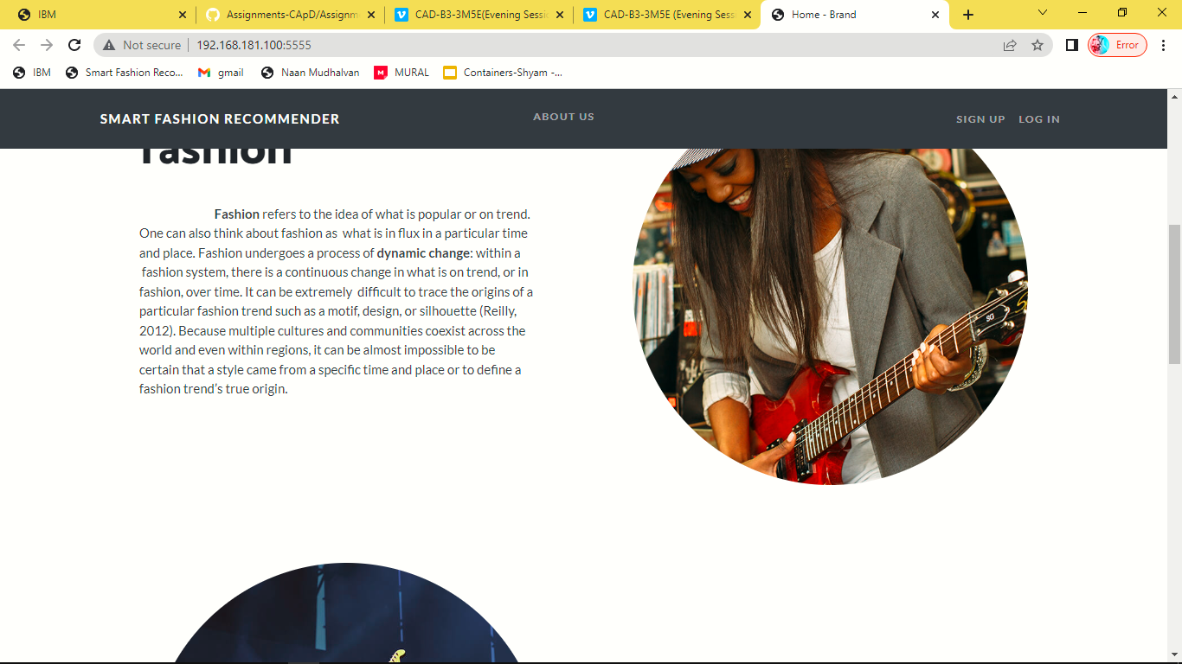

About page:

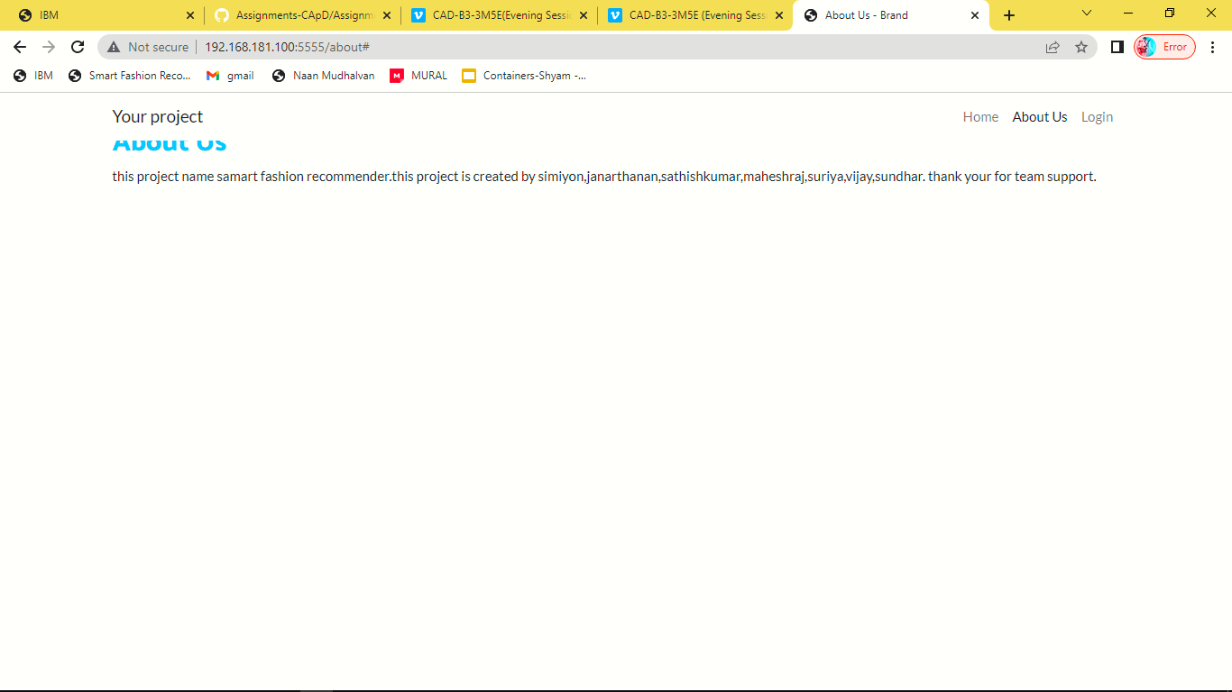

Register page:

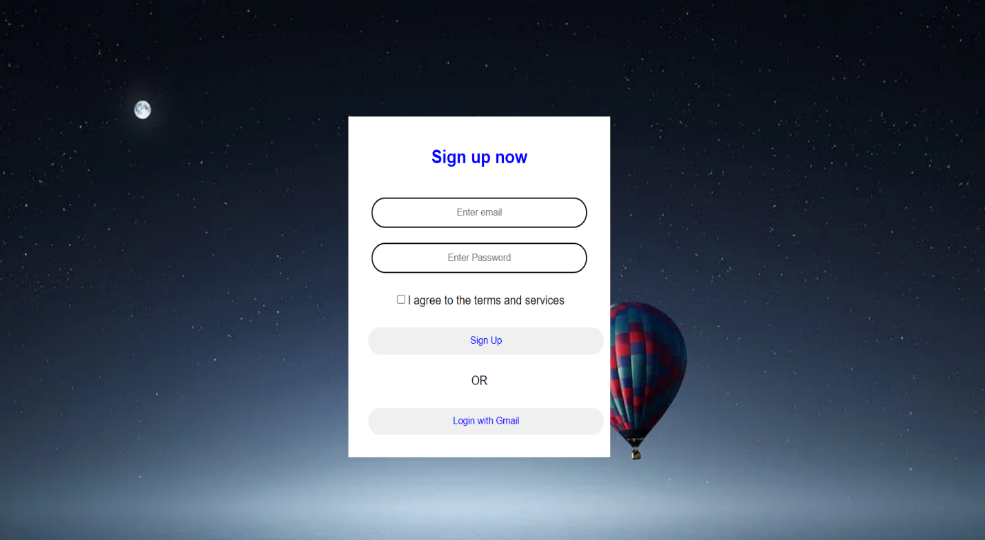

Sign in page:

